

SOROTI UNIVERSITY SCHOOL OF ENGINEERING AND TECHNOLOGY
DEPARTMENT OF ELECTRONICS AND COMPUTER ENGINEERING

DESIGN IMPLEMENTATION AND CALIBRATION OF A MULTI-SENSOR EDGE NODE

Laboratory 1: Technical Report Submitted by:
Hope Aarakit 2401600080
Elijah Otala 2401600343

Table of Contents
Objective and Competency Being Demonstrated 3
System Architecture and Hardware 3
Sensor Interfaces and Sampling Design 4
Sensor Characterization and Data Quality 5
Edge Processing and Local Decision Logic 6
Python Data Analysis and Visualization 8
Analytical Plots Summary (Generated Panel): 8
Discussion and Engineering Interpretation 12
Limitations and Recommended Improvements 12
Recommended System Upgrades: 14
Conclusion 14
References (IEEE Format) 16

Objective and Competency Being Demonstrated
The primary objective of this laboratory deployment is to design, physically prototype, and validate a stable, low-cost multi-sensor edge node using the ESP32-WROOM-32D microcontroller. The node acquired temperature, humidity, light and motion readings at 1 Hz, calibrated the temperature channel against a reference thermometer, and logged 2,077 readings that were analysed in Python. Through this experiment, several core engineering competencies are demonstrated:
- Hardware Prototyping: Creating safe, common-bus electrical connections on a solderless breadboard using digital (I2C), analog (ADC voltage divider network), and discrete digital interfaces.
- Firmware Architecture: Developing clean, non-blocking embedded C++ software loops utilizing polling clocks (millis()) to enforce a deterministic 1 Hz sampling frame without processor starvation.
- Local Processing and Decisions: Implementing start-up offset calibration, invalid-reading rejection, a temperature-threshold LED indicator and a motion-triggered buzzer directly on the ESP32, while the 5-sample moving average and rate of change are calculated on the logged data in Python.
- System Metrology & Calibration: Characterizing a systematic temperature error in the SHT31 (about +3.2 °C against a reference thermometer), applying a one-point offset correction, and reporting the Mean Absolute Error (MAE) and Root Mean Squared Error (RMSE) before and after calibration.
- Data Telemetry Pipeline: Capturing the serial stream, converting it to CSV, structuring it in Pandas DataFrames, and generating descriptive statistics and engineering plots in Python.

System Architecture and Hardware
The edge node framework is organized into four separate hardware layers governed by the central ESP32 processing platform:
1.Acquisition Layer: Formed by the DFRobot Gravity digital SHT31 sensor (I2C ambient interface), a 2-leg Photoresistor LDR coupled with a 10k pull-down resistor (Analog ADC channel), and a DFRobot Gravity digital PIR motion sensor (Discrete input).
2. Processing & Edge Processing Layer: Powered by the dual-core 32-bit ESP32-WROOM-32D module. It oversees the non-blocking execution schedule, ignores invalid (NaN) readings, applies the calibration offset to the temperature, and makes the local LED and buzzer decisions.
3. Physical Indicator Layer: Consists of a current-limited Green Status LED (GPIO 26) that shows the temperature status, and a buzzer (GPIO 25) that sounds for 2 seconds after motion is detected.
4. T
elemetry Layer: Employs a UART-to-USB hardware serial interface bridge (115200 baud) to send one text line per second to a computer, where the log is saved and converted to CSV for Python analysis.

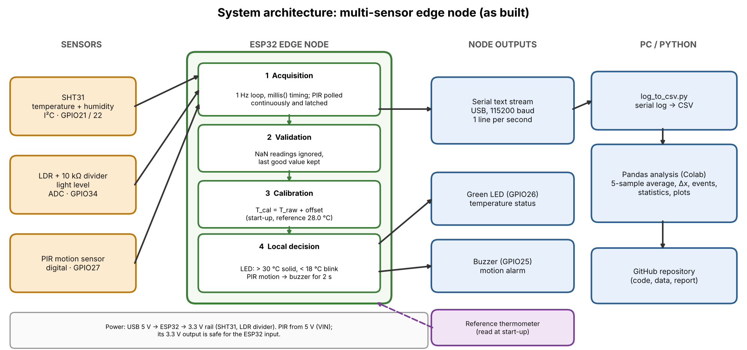
Figure 1 system architecture

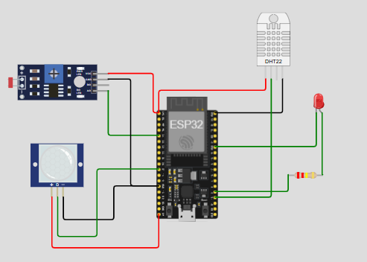
Figure 2: Simulation Diagram
In the Wokwi simulation shown in Figure 2, a DHT22 sensor stands in for the SHT31 temperature and humidity sensor.

Applied Safety Protocols and Prototyping Standards:
- Voltage Isolation Boundaries: The SHT31 digital sensor module and the analog LDR sub-circuit were connected strictly to the 3.3V power rail. This layout shields the ESP32 GPIO input blocks from over-voltage stress above their maximum threshold.
- PIR Power Allocation: The PIR motion sensor requires a minimum 5V input domain for reliable operation. Its VCC terminal was wired directly to the ESP32 5V/VIN terminal. Its internal logic driver naturally restricts its data output to a safe 3.3V line, allowing direct link to standard GPIO pins.
- Short-Circuit Mitigation: Horizontal breadboard power rails were cleanly divided: the top row was connected to 3.3V and the second row served exclusively as the common Ground (GND) return line. All circuit elements share this common reference point.

Sensor Interfaces and Sampling Design
The physical peripheral matrix links directly to the microcontroller pin array according to the operational parameters below:
Sensor/ actuator | ESP32 pin
SHT31 | GPIO 21(SDA)
 | GPIO 22(SCL)
PIR | GPIO 27
LDR (10 kΩ divider) | GPIO 34 (ADC)
LED | GPIO 26
BUZZER | GPIO 25

Sampling Interval Design Strategy:
To protect the node from processor stalls and timing drift, the firmware avoids blocking delays during normal operation. It implements an asynchronous schedule using millis() clock comparisons: every time the 1000 ms boundary is crossed, the SHT31 and LDR are read and one line (raw temperature, calibrated temperature, humidity, light and motion) is printed, so every channel has an effective sampling rate of 1 Hz. Between prints the loop polls the PIR continuously and latches any pulse, so a short motion event is not missed, and it updates the buzzer timer and the LED. The only blocking waits are in start-up: a 10 s settling time and 50 calibration samples at 200 ms for the temperature calibration, and a 30 s PIR warm-up. The firmware does not print a timestamp, so time in the exported CSV is reconstructed as one second per row (shown as "approximate" on the plot axes).

Sensor Characterization and Data Quality
Two logging sessions were recorded and combined into one CSV file of 2,077 one-second readings (about 34.6 minutes): the first 247 readings come from a short session and the remaining 1,830 from a longer one. The step down to 28.0 °C at about 250 s in Figures 4 and 6 is the join between the two sessions, not a real temperature change. The data were used to evaluate the performance of the physical components:
- SHT31 Temperature and Humidity: Readings were repeatable once the sensor had settled: the most stable 5-minute window (readings 1,387 to 1,686) has a raw temperature range of only 0.2 °C (standard deviation 0.06 °C), whereas the first 300 readings were not stable (standard deviation 1.16 °C) because of sudden rises of about 3 °C. Against the room reference thermometer, the sensor read about 3.2 °C too high at start-up (31.2 °C against 28.0 °C), a permanent systematic error much larger than the few tenths of a degree the SHT31 is rated for. This is most likely caused by board self-heating, as heat from the active ESP32 radiates through the breadboard into the SHT31 pins, but the cause was not isolated experimentally. After the first 250 s, humidity stayed between 45.2 % and 52.2 %.
- Analog LDR Light Sensor: Responded clearly to changes in lighting. Raw 12-bit ADC values ranged from 241 (dark) to 4095 (the ADC maximum, reached in one reading), with ordinary room light giving about 1,600 to 1,800 counts (median 1,667). Values are reported as ADC counts, not as a 0 to 1 ratio.
- PIR Motion Unit: Reported motion in 778 of the 2,077 readings (37.5 %), in 249 separate events, and stayed at 0 for quiet stretches of up to 157 s. Because the times when people entered the sensor's field of view were not logged, false triggers could not be counted.
Metrology Calibration Improvements:
A one-point offset calibration was embedded within the firmware to correct the systematic temperature bias. At start-up the node averages 50 SHT31 readings next to the reference thermometer (28.0 °C), computes offset = reference − sensor average, and adds it to every later reading (T_cal = T_raw + offset). The logged values show an applied offset of about −3.1 to −3.2 °C (Figure 6). The accuracy improvement was checked against the 28.0 °C reference over the whole log, assuming the room stayed at 28.0 °C (the room temperature was not recorded continuously):
- Mean Absolute Error (MAE): Decreased by 78 %, from 4.03 °C (raw) to 0.87 °C (calibrated).
- Root Mean Squared Error (RMSE): Decreased by 72 %, from 4.09 °C (raw) to 1.15 °C (calibrated). The error is zero by construction at the calibration point, so these values show the benefit of the offset but are not an independent validation; the remaining error comes from temperature swings after calibration, which a fixed offset cannot remove.

Edge Processing and Local Decision Logic
The ESP32 runs the following processing locally, before the readings are sent over the serial link:
- 1. Calibration and Validity Check: At start-up the temperature offset is computed against the reference thermometer and then added to every reading. A reading that comes back as NaN from the SHT31 is ignored and the last good value is kept, so one failed I2C read cannot corrupt the data. The reference temperature can also be typed into the serial monitor to recalibrate without re-flashing.
- 2. Local Temperature Threshold Decision: The calibrated temperature drives the green LED. Above 30.0 °C the LED stays solid ON (HIGH_TEMP), below 18.0 °C it blinks every 400 ms, and between 18.0 °C and 30.0 °C it stays OFF (NORMAL).
3. Motion-Triggered Buzzer: Any PIR pulse turns the buzzer ON for 2 seconds, and the timer restarts while motion continues. A latch records any pulse between prints, so short motion events still appear in the log.
The following processing was applied afterwards in Python on the logged data:
- 5-Sample Moving Average Filter: Each calibrated temperature value is averaged with the four previous values (a pandas rolling window of 5), creating a low-pass filter. It reduced the sample-to-sample noise (standard deviation of the one-second change in raw temperature) from 0.054 °C to 0.034 °C, a 37 % reduction, at the cost of a delay of about 2 seconds during sharp changes (Figure 7).
- Rate of Change: Δx = x(t) − x(t−1) of the calibrated temperature. It stays within ±0.2 °C/s except during the two sudden rises in the first session, where it peaks at 0.8 °C/s, so it flags these events.
- Event Detection: The status label is HIGH_TEMP when the calibrated temperature exceeds 30.0 °C and NORMAL otherwise: 190 readings (9.1 %) in 3 separate events. Motion events are counted when the motion flag changes from 0 to 1 (249 events).

Python Data Analysis and Visualization
The serial logs were converted to CSV with a Python script and ingested into a Jupyter notebook (Google Colab) using Pandas (raw_sensor.csv, 2,077 rows covering about 34.6 minutes at 1 Hz). The columns temp_raw, temp_cal, humidity, light and motion come directly from the log, and temp_filt is the 5-sample moving average of the calibrated temperature. Processing the 2,077 data rows yielded the descriptive metrics summarized below:
- Temperature Metrics (°C): Raw Mean: 32.03°C | Peak Max: 35.10°C | Lowest Min: 31.10°C | Sample Standard Deviation: 0.740. Calibrated Mean: 28.87°C | Peak Max: 32.00°C | Lowest Min: 28.00°C | Sample Standard Deviation: 0.747
- Relative Humidity Metrics (%): Ingested Mean: 48.67% | Peak Max: 73.50% | Lowest Min: 45.20% | Sample Standard Deviation: 3.527
- Light Metrics (12-bit ADC counts, 0-4095): Ingested Mean: 1874.5 | Peak Max: 4095 | Lowest Min: 241 | Sample Standard Deviation: 783.0 (coefficient of variation 41.8 %, the largest of the channels; humidity 7.2 %, raw temperature 2.3 %)
- System Flag Event Matrix Counts: 0 Invalid Readings (NaN or out of range) | 3 High Temp System Alert Invocations (190 readings above 30.0°C) | 249 PIR Motion Events (778 readings with motion)
Figure 3 shows the offset-only calibration fit (gain fixed at 1) against the reference thermometer, before and after correction; the dashed line marks ideal agreement (y = x).
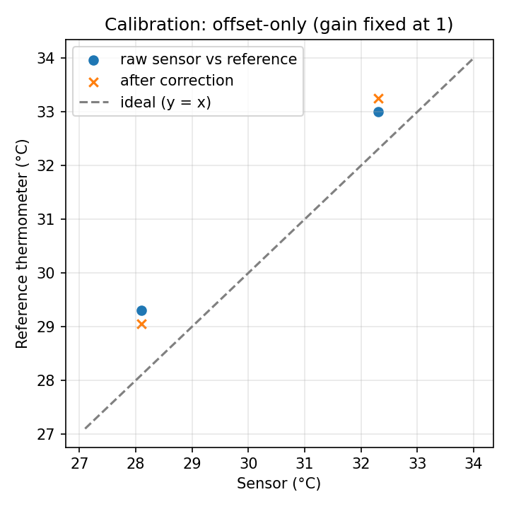
Figure 3: Calibration Diagram

GRAPHS

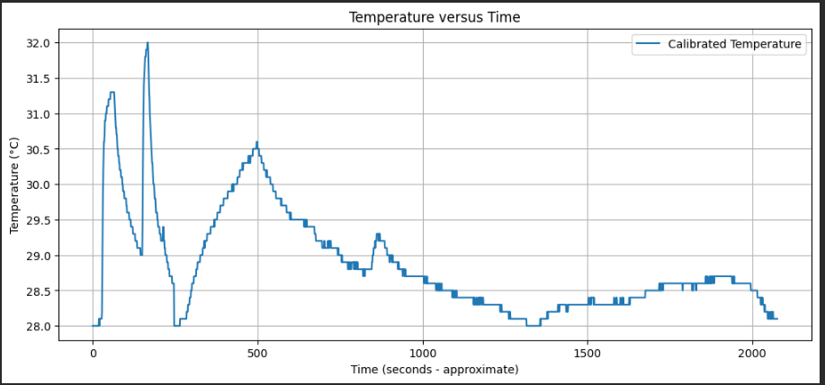
Figure 4: Temperature Vs Time Diagram

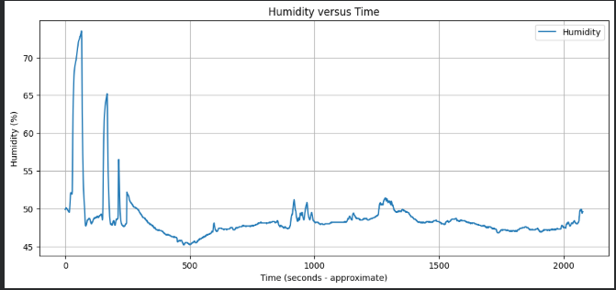
Figure 5: Humidity Vs Time Diagram

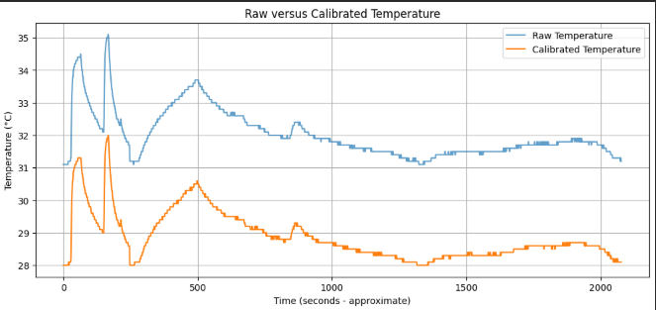
Figure 6 raw vs calibrated temperature

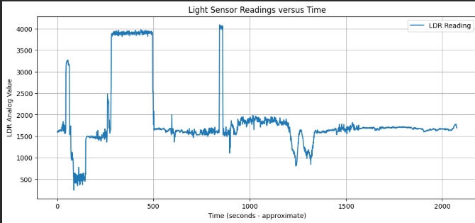
Figure 7 LDR Sensor vs time

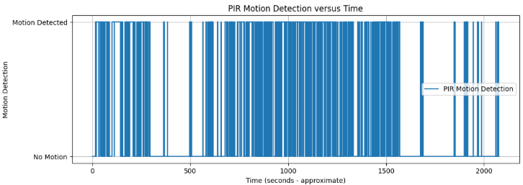
Figure 8 PIR sensor reading vs time

Discussion and Engineering Interpretation
Shifting data filtering and threshold checking directly to the localized edge computing layer offers significant advantages for real-world wireless sensor networks.
The primary advantage centers on the system's power budget. Operating an ESP32's wireless radio (WiFi or Bluetooth) requires substantial current, typically between 120 mA and 240 mA during active transmission bursts, whereas running local filtering and threshold checks on the CPU needs only a few tens of milliamps. These are datasheet-order estimates; no current measurements were made in this lab.
If the edge node continuously transmits every single raw, unverified data sample at 1 Hz, the battery life of a field deployment is greatly shortened. By executing filters locally, compressing data arrays into statistical summaries, and activating the radio only during critical events (for example HIGH_TEMP or a motion event), the system minimizes radio uptime, reduces network bandwidth requirements, and extends the node's operational lifespan. In the logged data, 99 % of the one-second changes in calibrated temperature were 0.1 °C or less (83 % were exactly zero), so almost every raw transmission would carry no new information.
Answers to the engineering analysis questions:
1. Subsystems: acquisition (SHT31, LDR, PIR), processing (the ESP32 samples, calibrates and decides), indication (LED and buzzer) and telemetry (USB serial link to Python).
2. Effective sampling rate: 1 Hz for every channel (one printed line per second). The PIR is polled continuously and latched, so its detection is not limited by the 1 Hz report.
3. Greatest variability: the light channel (standard deviation 783 counts on a mean of 1875, 41.8 %), against 7.2 % for humidity and 2.3 % for raw temperature, because the lighting was deliberately changed (bright source, room light and shade).
4. Systematic error revealed by calibration: the SHT31 read about 3.2 °C above the reference thermometer (31.2 °C against 28.0 °C).
5. Effect of calibration: under the stated assumption that the room stayed at 28.0 °C, MAE fell from 4.03 °C to 0.87 °C (78 %) and RMSE from 4.09 °C to 1.15 °C (72 %).
6. Effect of filtering: the 5-sample moving average reduced the sample-to-sample noise by 37 % (0.054 °C to 0.034 °C) but delays fast changes by about 2 s, so the filtered value suits status display and the unfiltered value suits event detection.
7. Edge versus transmitted data: calibration, validity checks, filtering and threshold and motion decisions belong on the node; what is transmitted should be the filtered value, status changes and event flags, plus a periodic summary, with raw samples only around an anomaly.
8. Energy if every raw measurement were transmitted: the radio would be active almost continuously and dominate the energy budget, as discussed above, while most of the transmitted values would be unchanged.

Limitations and Recommended Improvements
System Limitations Identified:
- Thermal Crosstalk: The SHT31 read about 3.2 °C above the reference, most likely because of parasitic board self-heating from its close physical proximity to the ESP32 module on the breadboard layout; this cause was not isolated experimentally. The sudden 3 °C rises in the first session, with humidity rising at the same time, also suggest handling or breath near the sensor.
- Filter Time Lag: The simple 5-sample moving average filter introduces a delay of about 2 seconds, which slows the response to sudden temperature changes.
- LDR Light Mapping: The photoresistor voltage divider response curve is non-linear, which compresses measurement resolution in extremely bright or dark settings.
- Single-Point Calibration: Only one reference point (28.0 °C) was used, so gain error cannot be separated from offset, the room temperature during the log was not recorded, and the calibrated values were not independently validated.
- No Timestamps and Joined Sessions: The firmware does not print a timestamp, so time is reconstructed as one second per row, and the CSV joins two logging sessions at about 250 s.
- Processing Done Offline: The moving average, rate of change and event counting were done in Python, not on the ESP32, and the plausibility range checks were also applied offline (the firmware rejects only NaN readings).
- PIR False Triggers: The times when people entered the sensor's field of view were not logged, so false triggers could not be counted.

Recommended System Upgrades:
- Physical Thermal Shielding: Move the SHT31 sensor off the main breadboard onto an isolated external cable assembly to eliminate internal heat radiation bias completely.
- Power Domain Optimization: Modify the firmware to put the ESP32 into low-power Deep Sleep mode between its 1-second sampling milestones, reducing baseline idle current to microamps.
- Advanced Adaptive Filtering: Replace the standard moving average logic with a discrete Kalman Filter algorithm to remove white noise without adding response delay lag.
- Two-Point Calibration: Calibrate at two stable temperatures and fit a gain and offset, then validate on readings that were not used in the fit.
- On-Device Filtering and Timestamps: Add a 5-sample buffer, the rate of change, the status string and a millis() timestamp column to the firmware output.

Conclusion
This laboratory deployment demonstrates a working multi-sensor edge node on the ESP32. An SHT31 temperature and humidity sensor, an LDR and a PIR sensor were sampled at 1 Hz without blocking delays, and 2,077 readings were logged and analysed in Python with no invalid values. A one-point calibration removed a systematic +3.2 °C temperature error and reduced MAE by 78 % and RMSE by 72 % under the stated assumption, and a 5-sample moving average reduced the sample-to-sample noise by 37 %. Local decisions (the LED temperature status and the motion-triggered buzzer) run on the node, and the clean serial stream converts directly to CSV for Python analysis. The main gaps are a second calibration point, on-device filtering with timestamps, and a longer stable baseline; closing them is the next step toward a field-ready IoT analytics node.

References (IEEE Format)
[1] ESP32-WROOM-32D Microcontroller Technical Datasheet, Rev. 3.4, Espressif Systems, 2024.
[2] SHT31-D Digital Temperature and Humidity Sensor Breakout User Guide, Adafruit Industries, 2022.
[3] W. Stallings, Wireless Communications & Networks, 2nd ed. Upper Saddle River, NJ: Pearson, 2005.
[4] Wireless Sensor Networks, Laboratory Guide 1: Design, Implementation and Calibration of a Multi-Sensor Edge Node, course handout, 2026.
l) Repository Link / File Structure
GitHub Repository Active Endpoint Link: https://github.com/hopeopolot/lab_wsn
Wokwi simulation link: https://wokwi.com/projects/476490188961995777

